

**INTERNET OF THINGS**

AMBIENT ASSISTED LIVING

INTELLIGENT CAR WITH SAFTEY AND GARAGE AUTOMATION (ICSGA)

**Professor:** Prof. Giuseppe Desolda

**GROUP FOUR**

**ALEX PRAVEEN DASS**

**(MAT NO: 725190)**

**SHANMUGAPRIYA BASKARAN**

**(MAT NO: 725189)**

Contents

**Ambient Assisted Living Scenario (Refined)** 3

1. Explore: 3

2. Challenges: 3

3. Combine - Sketch 4

**Story** 5

4. Refine 8

**Innovation:** 8

**User Friendly:** 8

**Utility:** 8

**Time Saver:** 9

# **Ambient Assisted Living Scenario (Refined)**

## Explore:

Mr. Stark is 86 years old who lives with his grandson Peter. Stark owns an old 1965 Ford Mustang which he loves more than anything. Stark Drives his car every day to meet his friends and to the golf course. In spite of his old age Stark drives on his own and never lets anyone to touch his car as it is one of the rarest car in the country. So there are many occasions in which his car was attempted to be stolen numerous times. Peter is very much concerned of his grandfather’s wellbeing and he wanted to secure his grandfather’s favourite and rarest car. So, he decided to upgrade the car without spoiling its originality to satisfy his needs of concerns. So he hired some professionals who is also an expert in Ambient Assisted living to install an IOT device that is **“Intelligent Car with Safety and Garage Automation (ICSGA)”** to help him monitor his grandpa’s car and help him drive safe back home every day.

 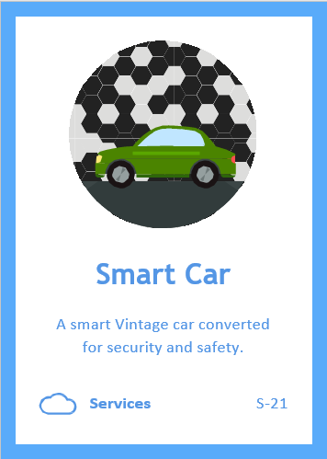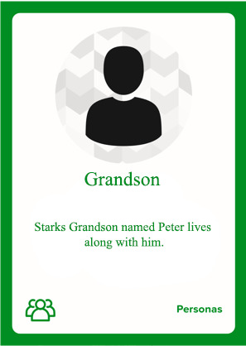

## Challenges:

Since Mr. Stark is very old he has certain health conditions which he struggle with, firstly he has a habit of forgetting things quite a lot. Then he is always prone to jump scares or panic attacks because of his old age anxiety. So considering all these things in practicality he has these following challenges.

Stark always forgets his car keys, so he needs a password protected car door lock just in case he forgets his keys. So, Stark may forget his keys but not his birth year so he has planned to set that as a password.

As we saw earlier his car is one of the rarest in the country so while it’s parked outside the golf course there is a chance for someone to steal it, so it requires a modern day tech alarm to notify both him and his grandpa stating that someone is trying to steal the car in anyway.

Initially in their house they had a manual garage door that is really narrow and requires a lot of care to bring the car outside and it does require quite a lot of effort to screw up/lift the garage door all the way up all by himself at his old age. So, Peter decided to make him an automatic remote accessed garage opener.

Sometimes when he parks his car in the golf ground parking he may find the other car parked on the both sides in which he has to wait till someone takes their car away so that he can get inside his driver’s seat and start the car. So peter decided to provide him a remote car operator in which it allows him to turn on the headlights, move the car forward, reverse and halt with a touch of a button.

If in case Stark meets with an accident there should be a device that sends an instantaneous message to Peter, the police and the nearby authorities for instant action to help him because Stark and Peter live in the country side not in a Metropolitan City so emergency assistance is always not instantaneous.

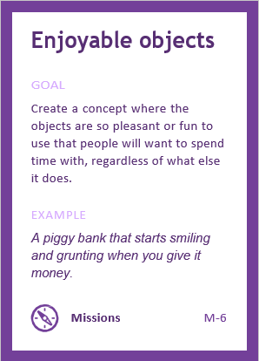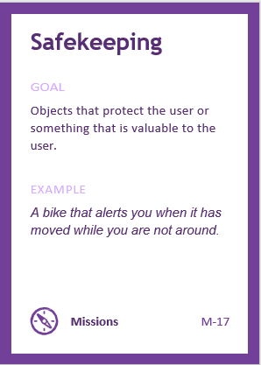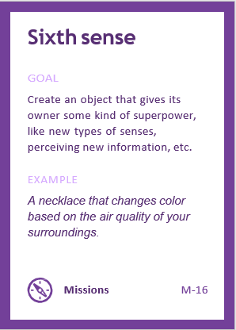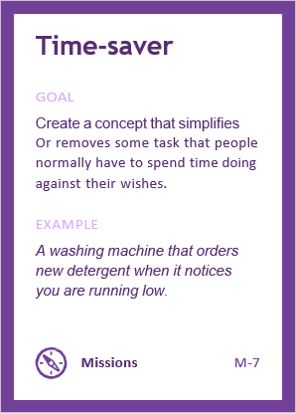

## Combine - Sketch

The AAL architecture is integrated by IOT devices, these devices are generally resource-constrained devices in terms of processing, memory and storage capacities available as a smart watch and application that can be downloaded in any smart devices like mobile, tab etc. These devices collect and transmit data to the Smart IOT Gateway which acts like a bridge between this device and internet or cloud.

* At first the first mode of security is the password protected car door which is always turned on while the engine is off. So the car is installed with the latest push button start along with the key hole. The car’s door will open only if the password is entered correctly. If the password is entered wrong it will send a notification to Stark’s cell phone and peter’s cell phone at the same time stating that someone has tried to access the car door with a wrong password. If the password is entered correctly then it opens the lock and lets stark inside.
* Before stark sits on the driver’s seat, he can simply press the open button from the wall to open his garage door. Once he moves the car away from his house then there will be a sensor outside to detect that the car has completed moved out and initiates the garage to close the garage door.
* But when he comes back home to his garage to park the car the external sensor outside the garage will sense the motion of the car and triggers the garage door motor to activate the open module to open the garage autonomously to let him get inside his garage, as soon as the car goes inside the door if the sensor fetches another motion it keeps the door in the idle state. Stark can safely close the garage door manually from inside pushing the button.
* When Stark goes out in his car there is a can be unfortunate moments in which he may or may not be indulged in an accident. So, there is a smart sensor placed in the front and back bumper of the car. In an unfortunate event if the button is triggered it will turn on the airbags and send the distress message to his grandson Peter and to the emergency care and to the Police station. If the impact is from the sides of the car then there is an inbuilt steering mounted button to activate the accident sensor that will also send out the distress messages.
* After Stark parks his car since it’s a rare care anyone can try to steal it, so once the car is parked a manual security system can be activated which will monitor the car’s all the doors. Since the cars driver’s door is password protected the person who tries to steal the car will try the other doors or he’ll try to break in to the car through the window, the security system has the force sensors in all the door handles and it’s also attached to the windows. If someone tries to break through the system will trigger a vigorous alarm and sends out a security breach message to both Peter and Stark to alert them about their car safety.
* If Stark has hard time to find his car during a dark evening time, he can turn on the car lights and turn on the car along with the heaters/air conditioners to prepare the car for a comfortable ride. If the car is stuck in between two other cars in both the side he can accelerate the car to back and forth to retrieve the car from the parking zone.

### **Story**

Stark just like every day prepares his Golf kit to go play some golf. Peter is working from home due to the covid-19 situations. Stark goes to the garage to his car and enters the password lock which is his date of birth. Once the password is entered the car door opens. Then he pushes the garage open button to open the garage to takes his car out. Once the car is out the garage closes the garage door automatically.

Then he starts driving to the freeway and parks his car near the Mc Donald’s to grab some breakfast. He puts the car in manual lock and goes into the restaurant with any concern, well thanks to his cars security system. After finishing his breakfast he comes to the parking lot to start his journey again to the golf course, but there is a problem.

Cars are parked very close in both the sides and he cannot access neither the driver seat nor the password keypad. Thanks to the Autonomous driving Stark uses his car remote and turns off the car security then he uses the forward accelerate button to slowly move the car to the front. As soon as the car is free on the sides he enters his car password and gets inside the car and starts driving.

Then he parks the car turns on the manual car security and goes off cool to play some golf with his buddies. A guy sees the car and was astonished as it was his dream car. So this guy pulls the door handle to see if the car’s door is open so that he could take a look inside, the car security triggers the alarm and sends out notification to both Peter and Stark and also puts out a really loud alarm. The securities of the golf court rushes to the parking lot to see what’s wrong. The mysterious person flees away realizing that he tripped the alarm out of fear. Stark was informed that his car was safe by the golf court securities and everything was okay. Peter called Stark seeing the notification to check with his grandpa to see what’s happening. Stark informed Peter that everything is okay and safe.

One his way back home near his house stark pulled over his car for a traffic stop, a pizza delivery guy came really fast in his scooter as he was late for a delivery, but he crashed into Stark’s car’s rear bumper. The accident sensor triggered a distress alarm to peter, nearby police station and to the emergency health care centre to send out an ambulance to the triggered location. Luckily Stark was alright but the delivery guy was severely injured. Thanks to the accident sensor the police and ambulance arrived in right time. The police recorded the accident for Stark’s insurance claim to fix his bumper and the ambulance was useful for the delivery guy to help him with his injuries. Peter arrived to the scene to check the wellbeing of his grandpa and found him safe and secured.

Then Peter and Stark drove back home and drove his car inside his compound and approached near the garage, thanks to the autonomous garage opener as soon as the car’s front reached the desired distance the garage door automatically opened. Stark parked his car inside the garage and used the manual close button to close the garage door.

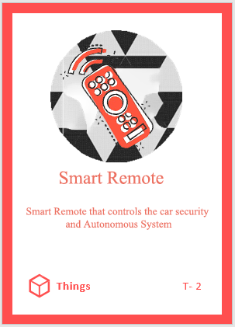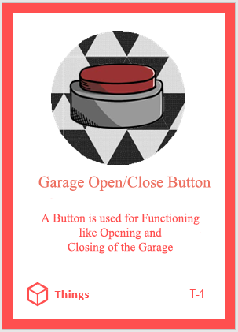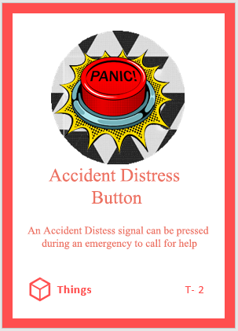

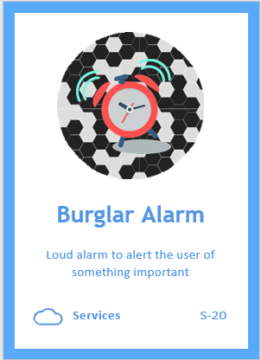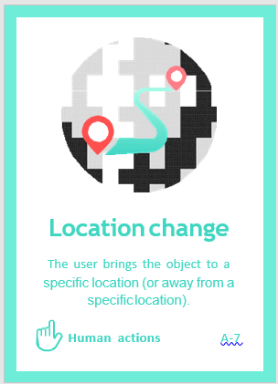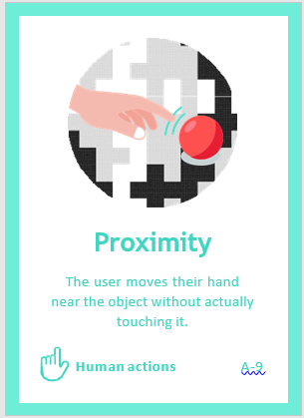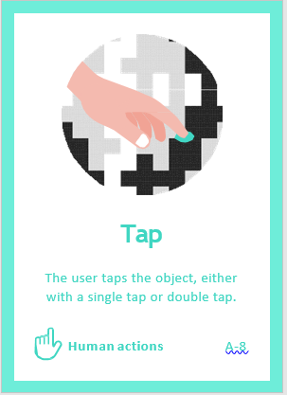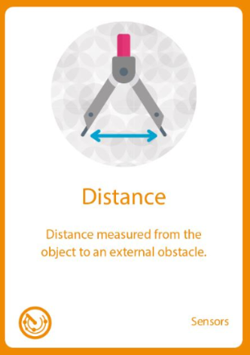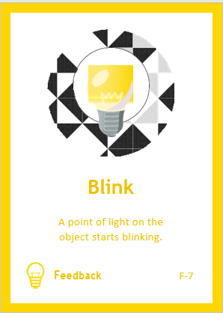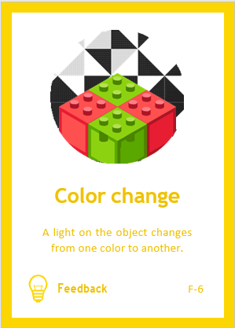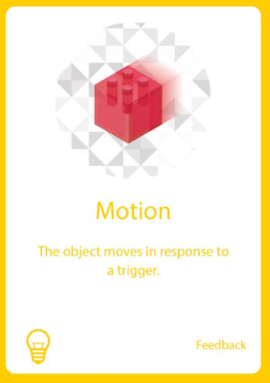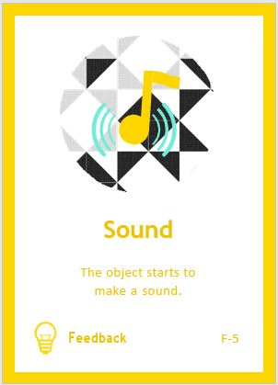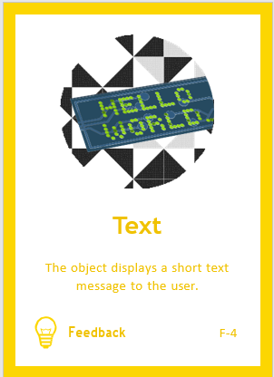

## Refine

The scenario defined here helps to withdraw a criterion for the activities supported by Ambient Assisted living to help the elderly living persons. Below are some of those:

### **Innovation:**

Always new set of Ideas has to be experimented, new ideas leads to new set of experiences, new set of experiences will lead to new set of problems and new set of problems will lead to new innovative solutions.

### **User Friendly:**

Every Design has to be made with lot of understandable, practical but yet easy/simple to use so that anyone can get access to technology no matter whether they are educated or not.

### **Utility:**

The system is simple and easy to utilize by elderly people with great ease and enjoyment.

### **Time Saver:**

Any type of technology should be designed to reduce the work of a human, on top of that each and every system has to be a time saving mechanism because less time more work and more work more time can be spent useful.

